HE3001 Tutorial 7 Solutions

1) Consider the paper industry. Suppose each paper mill produces in a way that pollutes the environment which imposes a negative externality on people living nearby.
Denote the market output by Q. Suppose the inverse market demand function for paper is $P=330-2Q$. There are 30 paper mills in the industry. The marginal private cost of an individual paper mill is $MC^{p}(q)=20+2q$. The marginal external cost, resulting from the pollution of paper production, is $MC^{e}(Q)=\frac{1}{10}Q$.
(a) What is the competitive equilibrium?
The individual supply curve is the inverse of the individual marginal private cost function:
$$p=20+2q_{j}$$
$$q_{j}=\frac{p-20}{2}$$
Thus, the individual supply curve is $S_{j}(p)=\frac{p-20}{2}$. The market supply curve is the horizontal summation of individual supply curve and thus $S_{mkt}\left(p\right)=30×S_{j}(p)=15p-300$
Therefore, the inverse market supply is $P=\frac{Q+300}{15}$.
The competitive equilibrium is given by the intersection of the (inverse) market demand and (inverse) market supply:
$$330-2Q=\frac{Q+300}{15}$$
$$Q=150$$
The equilibrium quantity is 150 and the equilibrium price is $330 – 2(150) = 30$.

(b) What is the social optimum?
The industry’s marginal private cost function is exactly the inverse supply curve derived earlier.
The marginal social cost is given by the sum of marginal private cost and external costs.
$$MC^{s}(Q)=MC^{p}(Q)+MC^{e}(Q)=\frac{Q+300}{15}+\frac{1}{10}Q=\frac{1}{6}Q+20$$

The social optimum, is the intersection between marginal social cost and inverse market demand:
$$MC^{S}\left(Q\right)=330-2Q$$
$$\frac{1}{6}Q+20=330-2Q$$
$$Q=\frac{1860}{13}≈143.08$$

The corresponding price is
$$P=330-2(\frac{1860}{13})=\frac{570}{13}≈43.846$$

(c) Is the competitive equilibrium the same as the social optimum? If not, what is the tax rate that results in the social optimum?
The desired (per unit) tax rate is the marginal external cost evaluated at the socially optimal quantity:
$$MC^{e}(\frac{1860}{13})=\frac{1}{10}(\frac{1860}{13})=\frac{186}{13}≈14.308$$
This tax rate will shift the MPC curve (up) such that it intersects the MPB curve at the social optimum.
$$P$$
$$20+\frac{1}{6}Q$$
$$330-2Q$$
$$20+\frac{1}{15}Q$$
$$A$$
With per unit tax

$$B$$
$$P_{B}$$

$$P_{S}$$

$$C$$
$$Q$$

With this tax, social welfare is sum of grey area (consumer surplus), blue area (producer surplus) and green area (taxes collected) minus dashed area (social costs). This is exactly equal to the triangle ABC which is the maximum social welfare that can be attained.

2) An airport is located next to a large tract of land owned by a housing developer. The developer would like to build houses on this land, but noise from the airport reduces the value of the land. The more planes that fly, the lower the profits that the developer makes. Let $X$ be the number of planes that fly per day and let $Y$ be the number of houses that the developer builds. The airport’s total profits are $48X-X^{2}$, and the developer’s total profits are $60Y -Y^{2} -XY$ .
Let us consider the outcome under various assumptions about institutional rules and about bargaining between the airport and the developer.
(a) “Free to Choose with No Bargaining”: Suppose that no bargains can be struck between the airport and the developer and that each can decide on its own level of activity. What will be the number of houses built and planes flying?
From the first order conditions of each of the airport’s profit maximization problems, we get
$$X=24$$
This holds no matter how many houses the developer builds.
From the first order conditions of the developer’s profit maximization problem, we get
$$60-2Y-X=0$$
Given that the airport is landing 24 planes, this condition becomes $60-2Y=24$. The profit maximizing number of houses for the developer’s profits is hence 18.
Total profits of the airport will be 576 and total profits of the developer will be 324. The sum of their profits will be 900.
(Note: In general, be careful not to substitute X into the developers profit function before taking the FOC as this implies that their decisions are sequential. You have to solve for the solution of the two simultaneous FOCs. While the answer here will be the same for both methods, this will not hold if X was also a function of Y!)

(b) “Strict Prohibition”: Suppose that a local ordinance makes it illegal to land planes at the airport because they impose an externality on the developer. What will be the outcome in the market?
No planes will fly due to the restrictions. The developer will build 30 houses and will have total profits of 900.

(c) “Lawyer’s Paradise”: Suppose that a law is passed that makes the airport liable for all damages to the developer’s property values. Since the developer’s profits are $60Y -Y^{2}-XY$ and his profits would be $60Y -Y^{2}$ if no planes were flown, the total amount of damages awarded to the developer will be XY. What will be the number of houses built and planes flying?
If the airport flies X planes and the developer builds Y houses, then the airport’s profits after it has paid damages will be $48X - X^{2} - XY$ . The developer’s profits including the amount he receives in payment of damages will be $60Y -Y^{2}-XY +XY =60Y -Y^{2}$.
To maximize his net profits, the developer’s FOC is:
$$60-2Y=0$$
He we hence choose to build 30 houses no matter how many planes are flown.
To maximize its profits, net of damages, the airports number of planes needs to satisfy the FOC:
$$48-2X-Y=0$$
Substituting $Y=30$ into this FOC gives $X=9$.
Profits of the developer (after compensation) will be $60×30-{30}^{2}=900$. Profits of the airport are $48×9-9^{2}-9×30=432-81-270=81.$ The sum of their profits will be 981.

Here, there is an assignment problem: the external costs of plane landings depend not only on the airport’s actions, but also the developer’s actions (Costs=XY); it hence becomes difficult to bargain over the assignment of these costs. Notice that if damages to the developer were just a function of $X$, say a$X$, then transferring these costs to the airport will result in the socially optimal outcome.

(d) “Merger”: Suppose that the housing developer purchases the airport. What is the profit function for the new joint entity? What will be the number of houses built and planes flying?
Their joint profits are $48X-X^{2}+60Y-Y^{2}-XY$. To maximise joint profits, we take the first order conditions wrt to $X$ and $Y$.
First order condition for $X:48-2X-Y=0$
First order condition for $Y:60-2Y-X=0$
Solving the simultaneous equations, we get $X=12$ and $Y=24$. Combined profit is 1008. (This is the efficent outcome because we are maximizing total profits which is assumed to be equal to social welfare).

(e) Explain why each of the institutional rules proposed from (a) to (c) does not reach an efficient outcome and has lower combined profits.
In (a), the airport does not bear the cost of damages from landing planes. In (b), planes are prohibited to land. The source of the externality is eliminated along with the benefit of airplanes. In (c), the airport bears the full cost of damages from landing but the developer bears none of the cost. Therefore, the developer overbuilds.

(f) “Dealing”: Suppose that the airport and the developer remain independent. If the original situation was one of “free to choose,” could the developer increase his net profits by negotiating with the airport to cut back one flight per day if the developer has to pay for all of the airport’s lost profits? Assume that this is legally enforceable.
Note that the question is saying that the developer has to pay at least any loss in airport’s profits.
To check whether a negotiation is possible, we need to see if the loss in the airport’s profits in less than the gain in the developer’s profits when flights are cut back by 1. Legal enforceability means that any party cannot renege on the contract.
Yes. Consider a change from the initial equilibrium of 24 planes to 23 planes. The profits of the airport decrease from 576 to 575. The profits of the developer assuming he sticks to 18 houses increase from 324 to 342 (In fact, it can increase even more if the developer changes his number of houses).
The increase in profits of the developer is greater than the drop in profits of the airport. Hence, it is possible to come to an agreement. In particular, a possible payment is $1≤p≤18$.

3) Tom and Jerry are roommates. They spend a total of 80 hours a week together in their room.
Tom likes loud music, even when he sleeps. His utility function is $U_{T} (C_{T},M) = C_{T} + M$, where $C_{T}$ is the number of cookies he eats per week and M is the number of hours of loud music per week that is played while he is in their room. Jerry hates all kinds of music. His utility function is $U_{J}\left(C_{J},M\right)= C_{J} -\frac{M^{2}}{12}$. Every week, Tom and Jerry each get two dozen chocolate chip cookies sent from home. They have no other source of cookies.
We can describe this situation with an Edgeworth-like box below.

Music

80

48
Cookies
Jerry
Tom

Since cookies are private goods, the number of cookies that Tom consumes per week plus the number that Jerry consumes per week must equal 48. But music in their room is a public good. Each must consume the same number of hours of music ($≤80$), whether he likes it or not.
Recall that each point in the box hence describes an allocation of cookies and music.
(a) Suppose the dorm’s policy is that you must have your roommate’s permission to play music. What will be the resultant allocation if Tom and Jerry can make no deals? Mark this allocation ($A)$ in the box and draw the indifference curves for Jerry and Tom passing through it. Shade the points, if any which would make both roommates better off than at point A.
(b) Suppose, alternatively, that the dorm’s policy is “rock-n-roll is good for the soul.” You don’t need your roommate’s permission to play music. What will be the resultant allocation if Tom and Jerry can make no deals? Mark this allocation ($B)$ in the box and draw the indifference curves for Jerry and Tom passing through it. Shade the points, if any which would make both roommates better off than at point $B$.
See part c) for the explanation of the location of A and B.
The equations of the indifference curves at A are:
$$C_{T}+M=U_{T}\left(24,0\right)=24$$
$$C_{J} -\frac{M^{2}}{12}=U_{J}\left(24,0\right)=24$$

The equations of the indifference curves at B are:
$$C_{T}+M=U_{T}\left(24,80\right)=104$$
$$C_{J} -\frac{M^{2}}{12}=U_{J}\left(24,80\right)=-508.333$$

Sketching them out gives the figure shown.

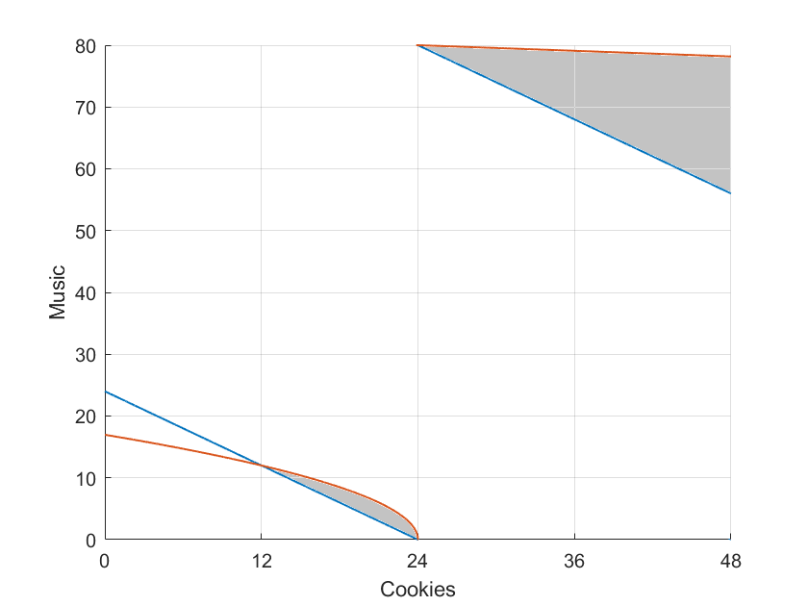
A
Jerry
Tom
B

(c) Who effectively owns the “property rights” over playing music in each of the cases a) and b)?
In case a), permission is needed to play music, so Jerry has the effective property rights. In case b), no permission is need to play music, i.e. Tom needs to be asked for permission to lower music, so Tom has the effective property rights. This is related to why the resultant allocations are $A$ with no music and B with full music respectively.

(d) Suppose in each of the cases (a) and (b), they are now allowed to make deals and that any deals can be enforced. What kinds of deals are possible for each case?
Since they must be willing to trade starting from the default option, any deals must lie in the shaded areas for (a) and (b) where both become at least better off.

(e) (Optional) After any deals, will the music outcome in case a) be the same as case b)? Explain why.
As seen from the figure, the final outcome after trade will lie somewhere in the respective bottom/top gray regions (as the starting point of trade is A and B respectively). As there is no vertical overlap between the two, it is not possible for the outcomes (of music) in case a) to be the same as in case b) after any deals are made.
This happens even though utility is quasi linear here (which fulfills one of the conditions of the Coase theorem) because Jerry does not have a high enough endowment of cookies to trade to reach the same amount of music as before which would actually be desirable. You can think of this financial constraint as transaction costs to bargaining. In the example in the lecture, there was no such constraint.
4) In El Carburetor, California, with a population of 1001, there is not much to do except to drive your car around town. Everybody in town is just like everybody else. While everybody likes to drive, everybody complains about the congestion, noise, and pollution caused by traffic.
A typical resident’s utility function is $U (m, d, h) = m + 16d - d^{2} - 6h/1000$, where $m$ is the resident’s daily consumption of Big Macs, $d$ is the number of hours per day that he, himself, drives, and $h$ is the total amount of driving (measured in hours per day) done by all other residents of El Carburetor. The price of Big Macs is $1 each. Every person in El Carburetor has an income of $40 per day. For simplicity, suppose it costs nothing to drive a car.
(a) If an individual believes that the amount of driving he does won’t affect the amount that others drive, how many hours per day will he choose to drive?
Take the derivative of $U (m, d, h)$ with respect to $d$.
$$16-2d=0$$
$$d=8$$

(b) If everybody chooses his best $d$, then what is the total amount $h$ of driving by other persons?
$$h=8×1000=8000$$

(c) What will be the utility of each resident?
Residents will use the whole income to buy Big Macs (because money does not enter the utility function), so $m=40$.
$U \left(m=40, d=8, h=8000\right)=56$

(d) If everybody drives 6 hours a day, what will be the utility level of a typical resident of El Carburetor?
$U \left(m=40, d=6, h=6000\right)=64$
Notice that by reducing driving, everyone has increased utility.

(e) Suppose that the residents decided to pass a law restricting the total number of hours that anyone is allowed to drive. How much driving should everyone be allowed if the objective is to maximize the utility of the typical resident?
We want to choose the value of d to maximize $U (m, d, h)$, given $m=40, h=1000d$.
(The reason we substitute $h=1000d$ is because a social planner who wants to maximise the utility of a typical resident needs to take into account the negative externality of driving from other residents.)
$$U \left(m, d, h\right)=40+16d - d^{2} - 6d$$
Take the derivative of $U (m, d, h)$ with respect to $d$
$$10-2d=0$$
$$d=5$$
This level of $d=5$ if chosen by everyone, will maximise the utility of each resident.
With this restriction in place, each resident will also choose $d=5$ resulting in the socially efficient outcome.

(f) The same objective could be achieved with a tax on driving. How much would the tax have to be per hour of driving?
Suppose tax is $x$ dollars. Every hour of driving will cost a person $x$ dollars that he can use to buy Big Macs. Thus, utility function becomes
$$U \left(m, d, h\right)= 40-dx + 16d - d^{2} - 6h/1000$$
Take the derivative of $U (m, d, h)$ with respect to $d$
$$16-x-2d=0$$
$$d=8-x/2$$
$$8-x/2=5$$
$$x=6$$
Thus, the tax we need is $\$6$ per hour of driving.

